**Music Data Analysis**

**Project Description:**

A leading music-catering company is planning to analyse large amount of data received from varieties of sources, namely mobile app and website to track the behaviour of users, classify users, calculate royalties associated with the song and make appropriate business strategies. The file server receives data files periodically after every 3 hours.

**Data Creation:**

Run mysql

sudo sevice mysqld start

Make sure all the scripts in Scripts have 774 permissions

Run below command:

Chmod 774 “path”

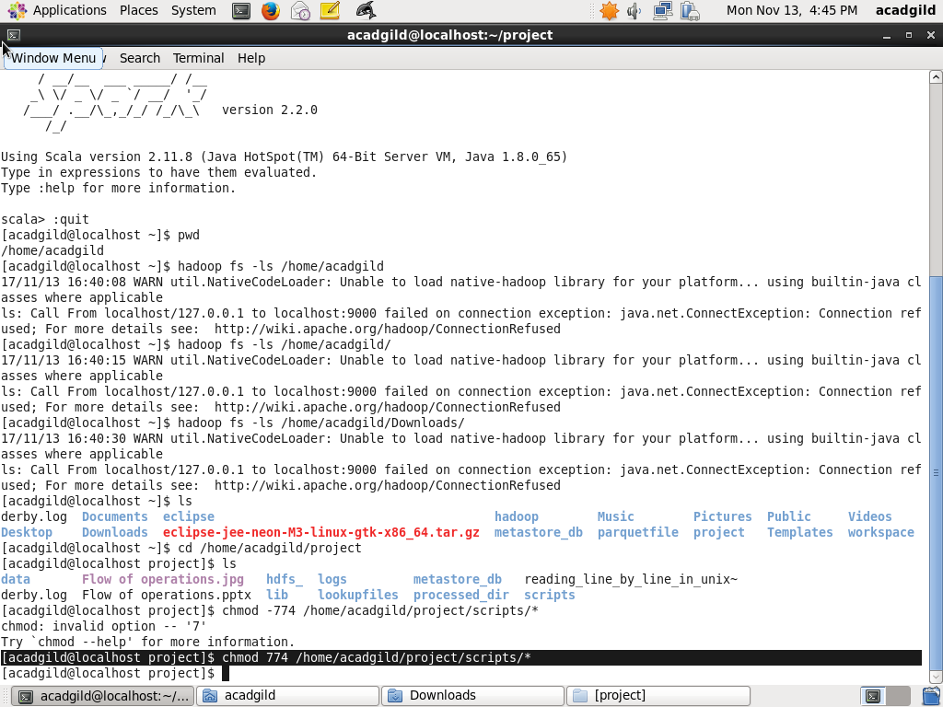

1. Generate Some Random Data coming from Web Application.(using python or UNIX scripting)

Sol: python /home/acadgild/project/scripts/generate_web_data.py

(Contains the set of records created Manually which contains both valid and Invalid Records in XML format )

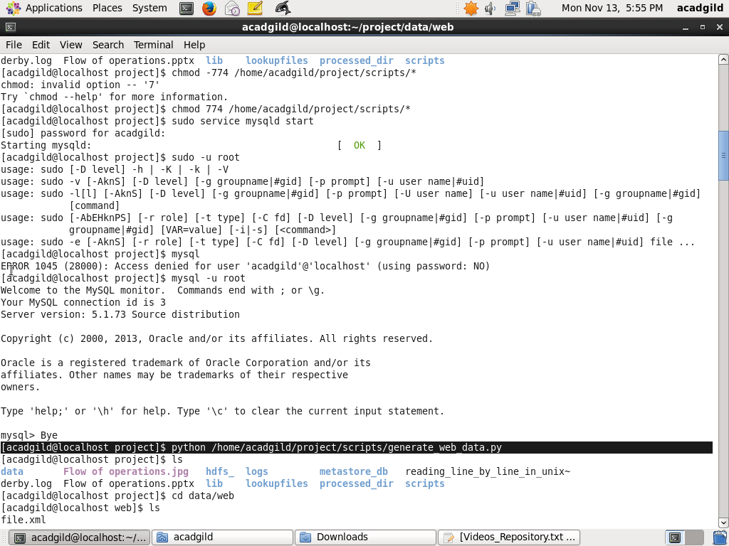

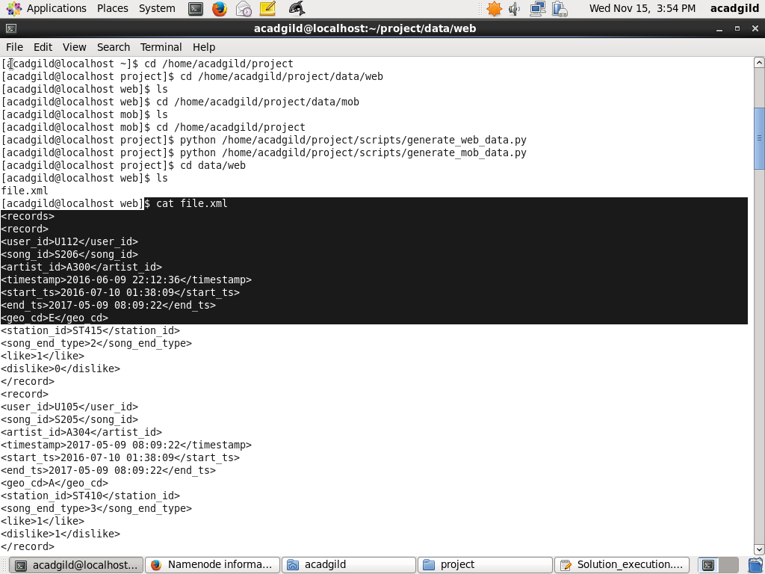

2. Generate some random data coming from mobile application

Sol: python /home/acadgild/project/scripts/generate_mob_data.py

(Contains the set of records created Manually which contains both valid and Invalid Records in CSV format)

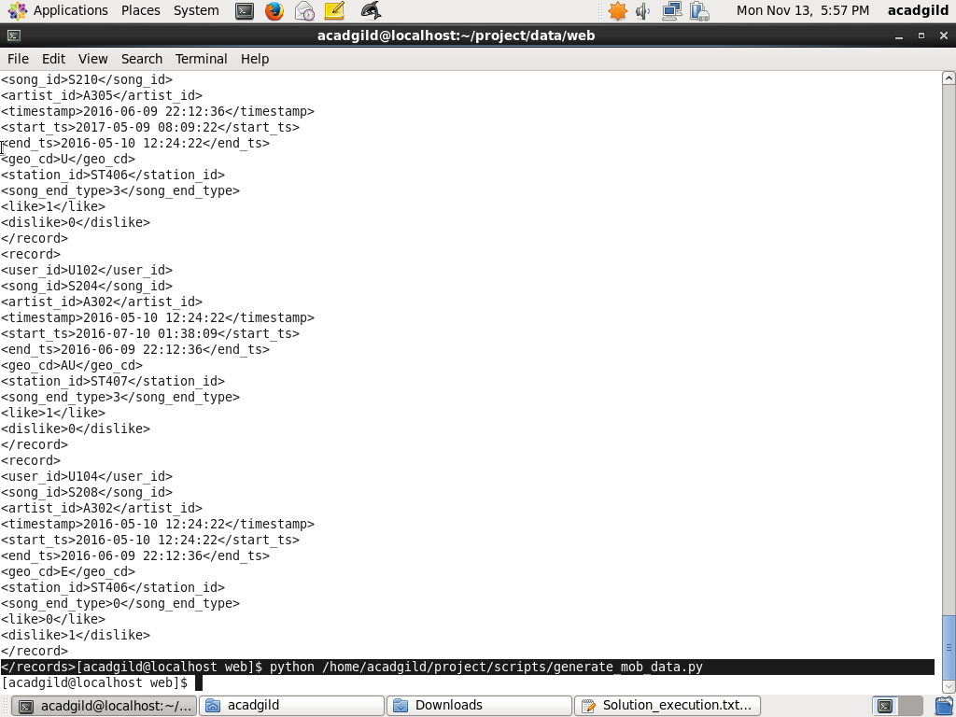

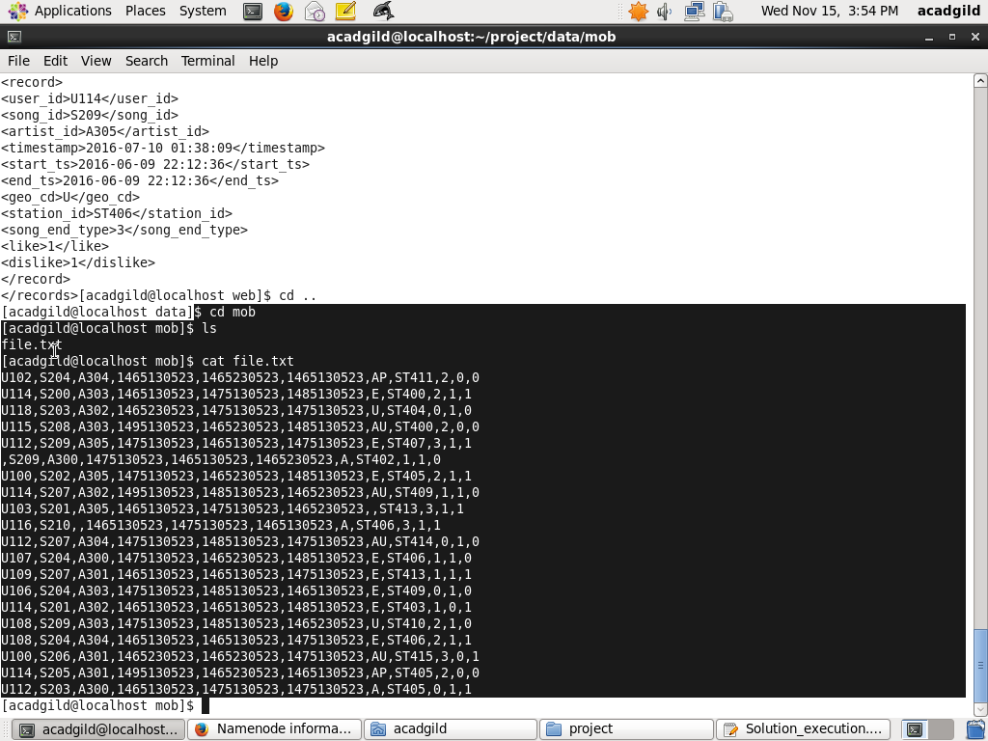

**Data Ingestion and Validation**

1. Data coming from web applications reside in /data/web and has xml format.
2. Data coming from mobile applications reside in /data/mob and has csv format. 3. 3. Data present in lookup directory should be used in HBase.
3. All the Timestamps must have the format of long Integer interpreted as Unix Timestamps.
4. If both Like and dislike are 1 ,consider it to be Invalid.

* Launch all necessary daemons

sh /home/acadgild/project/scripts/start-daemons.sh

(Start-deamons.sh contains the batch id..To run the same job again n again we need BatchId for differentiating the jobs)

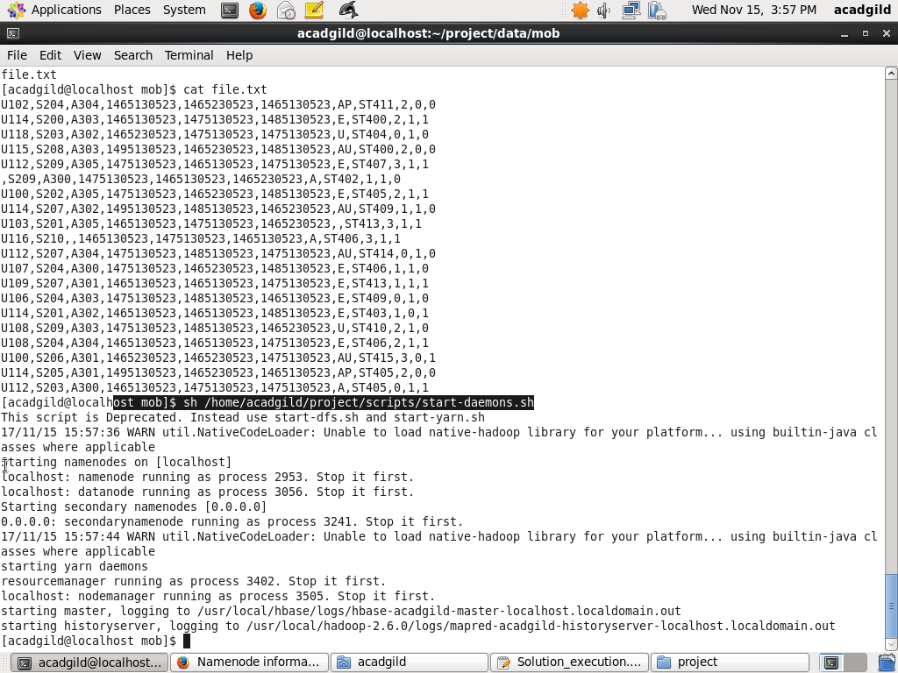

* Populates lookup tables

sh /home/acadgild/project/scripts/populate-lookup.sh

(Creating Required tables and loading the data from lookup files )

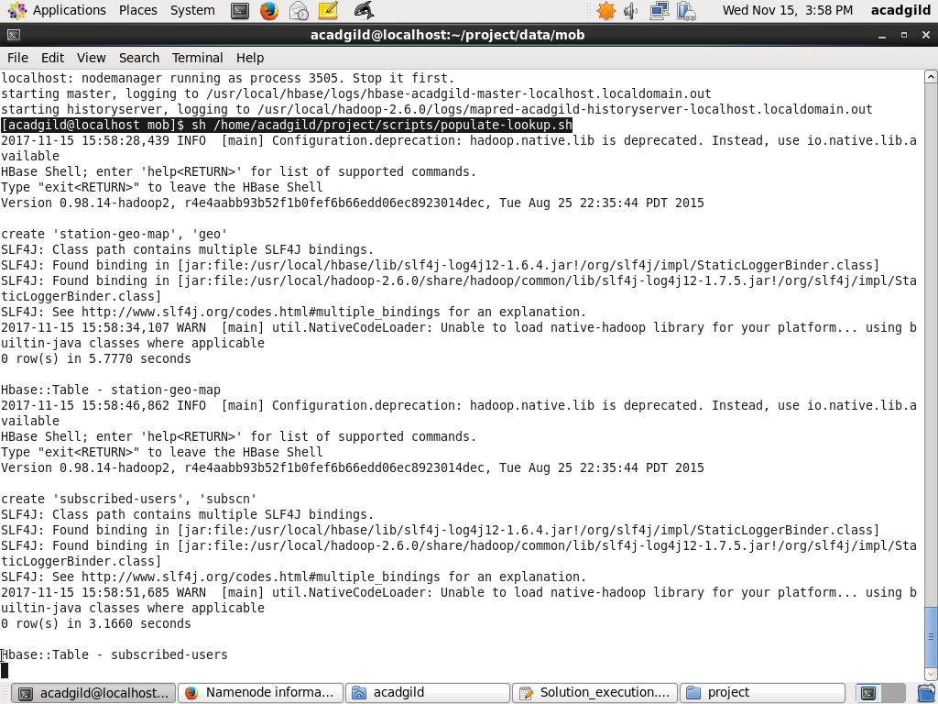

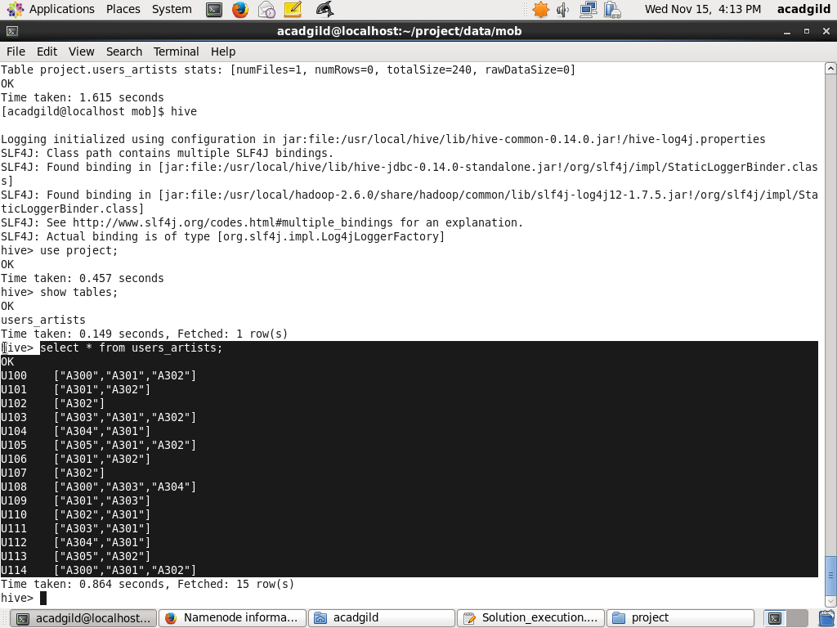

* dataformatting.sh -- Performs data formatting

sh /home/acadgild/project/scripts/dataformatting.sh

(Loading the files from Local(web and mob )to hdfs)

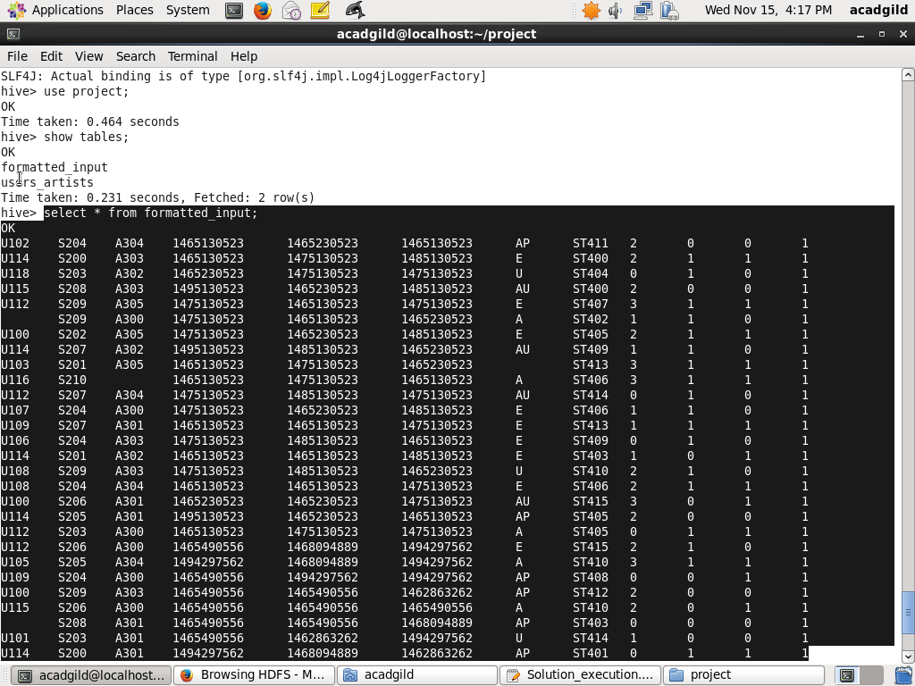

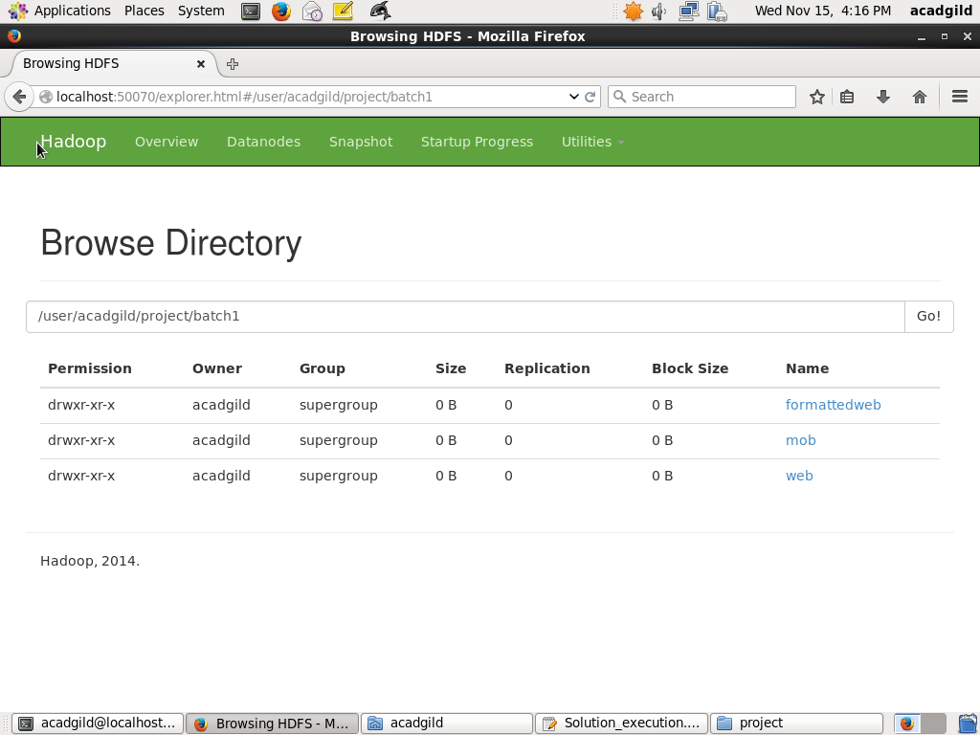

Pig query for Satisfying the Condition 4.

**Data Enrichment:(Rules)**

1. If any of the like or Dislike is Null or absent ,consider it as 0.
2. If the fields are absent consider lookup table for fields to get the values.
3. If corresponding lookup entry is not found ,consider that record to be invalid.

Lookup Table is in **Hbase** and Data is present in **hdfs**.

hive -f /home/acadgild/project/scripts/create_hive_hbase_lookup.hql

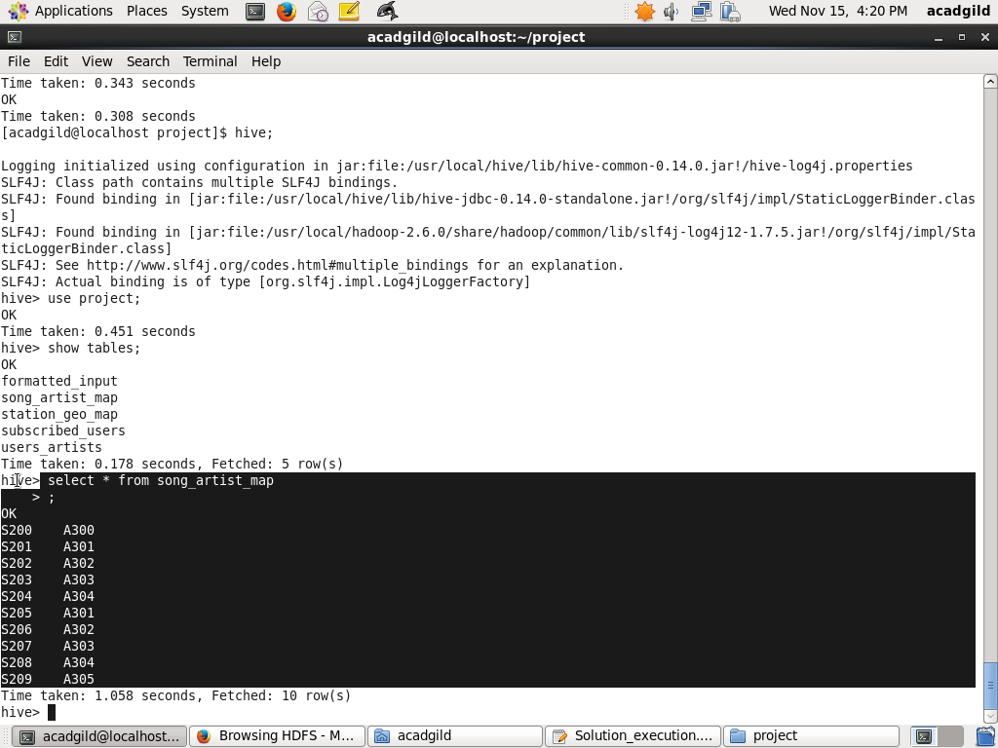

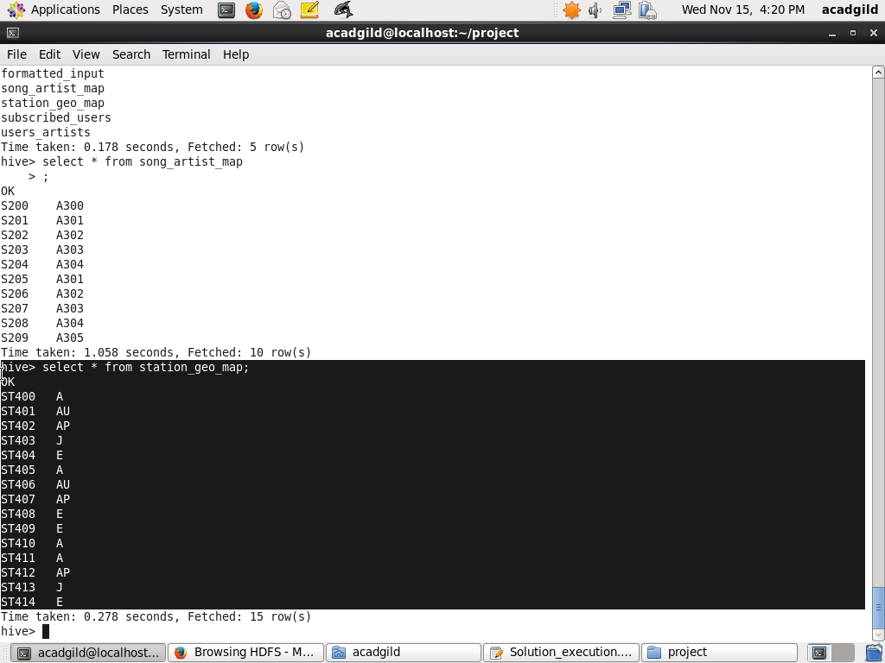

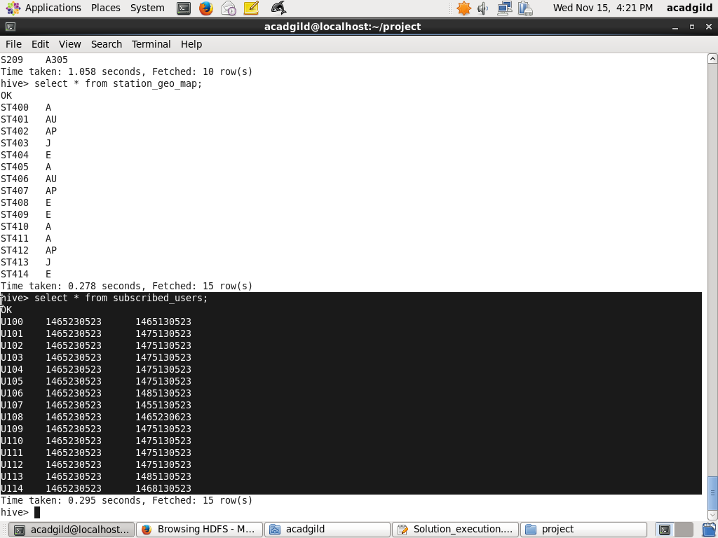

(Creating hive table that consists data of Hbase)

data_enrichment.sh -- Performs data enrichment and cleaning

sh /home/acadgild/project/scripts/data_enrichment.sh

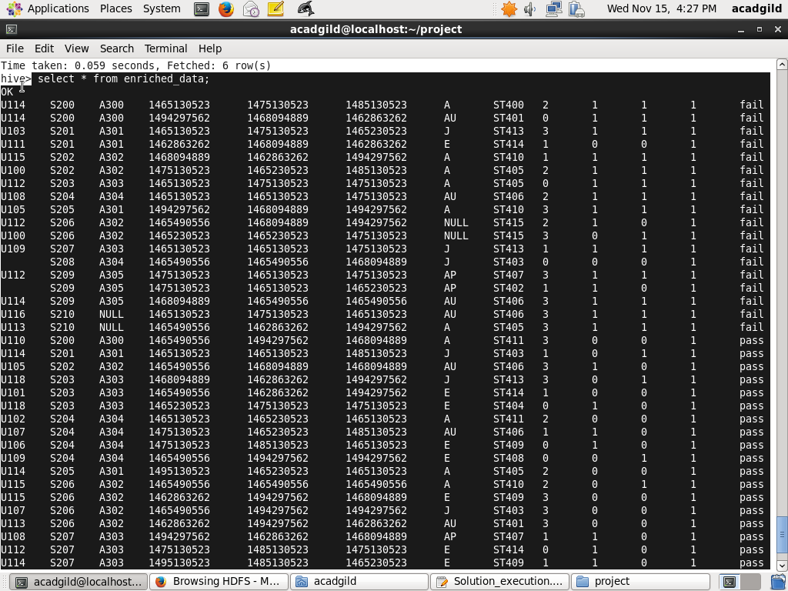

(Create a table which loads the data from previous table and check for null and lookup table if the value is present if not Assume that record to be invalid)

**Data Analysis:**

1. **Determine top 10 station_id(s) where maximum number of songs were played, which were liked by unique users.**

**Sol:**

CREATE TABLE IF NOT EXISTS top_10_stations

(

station_id STRING,

total_distinct_songs_played INT,

distinct_user_count INT

)

PARTITIONED BY (batchid INT)

ROW FORMAT DELIMITED

FIELDS TERMINATED BY ','

STORED AS TEXTFILE;

INSERT OVERWRITE TABLE top_10_stations

PARTITION(batchid=${hiveconf:batchid})

SELECT

station_id,

COUNT(DISTINCT song_id) AS total_distinct_songs_played,

COUNT(DISTINCT user_id) AS distinct_user_count

FROM enriched_data

WHERE status='pass'

AND batchid=${hiveconf:batchid}

AND like=1

GROUP BY station_id

ORDER BY total_distinct_songs_played DESC

LIMIT 10;

**Output:**

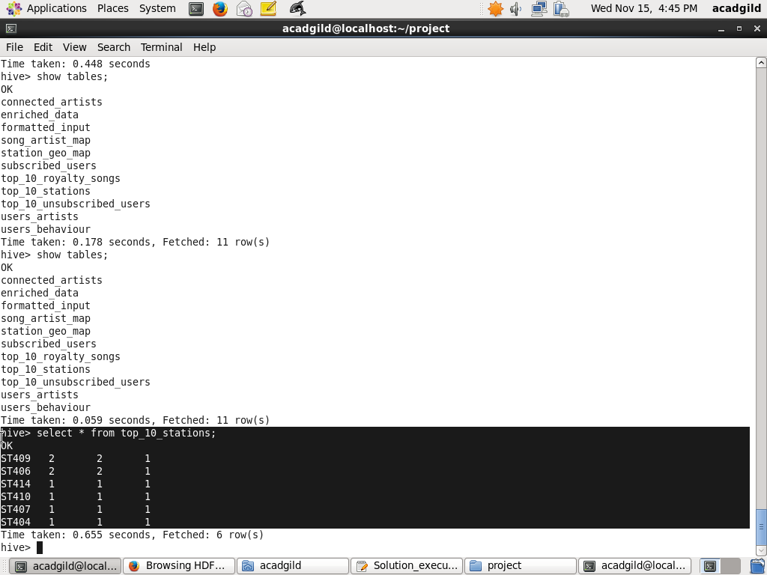

1. **Determine total duration of songs played by each type of user, where type of user can be 'subscribed' or 'unsubscribed'. An unsubscribed user is the one whose record is either not present in Subscribed_users lookup table or has subscription_end_date earlier than the timestamp of the song played by him.**

**Sol:**

CREATE TABLE IF NOT EXISTS users_behaviour

(

user_type STRING,

duration INT

)

PARTITIONED BY (batchid INT)

ROW FORMAT DELIMITED

FIELDS TERMINATED BY ','

STORED AS TEXTFILE;

INSERT OVERWRITE TABLE users_behaviour

PARTITION(batchid=${hiveconf:batchid})

SELECT

CASE WHEN (su.user_id IS NULL OR CAST(ed.timestamp AS DECIMAL(20,0)) > CAST(su.subscn_end_dt AS DECIMAL(20,0))) THEN 'UNSUBSCRIBED'

WHEN (su.user_id IS NOT NULL AND CAST(ed.timestamp AS DECIMAL(20,0)) <= CAST(su.subscn_end_dt AS DECIMAL(20,0))) THEN 'SUBSCRIBED'

END AS user_type,

SUM(ABS(CAST(ed.end_ts AS DECIMAL(20,0))-CAST(ed.start_ts AS DECIMAL(20,0)))) AS duration

FROM enriched_data ed

LEFT OUTER JOIN subscribed_users su

ON ed.user_id=su.user_id

WHERE ed.status='pass'

AND ed.batchid=${hiveconf:batchid}

GROUP BY CASE WHEN (su.user_id IS NULL OR CAST(ed.timestamp AS DECIMAL(20,0)) > CAST(su.subscn_end_dt AS DECIMAL(20,0))) THEN 'UNSUBSCRIBED'

WHEN (su.user_id IS NOT NULL AND CAST(ed.timestamp AS DECIMAL(20,0)) <= CAST(su.subscn_end_dt AS DECIMAL(20,0))) THEN 'SUBSCRIBED' END;

**Output:**

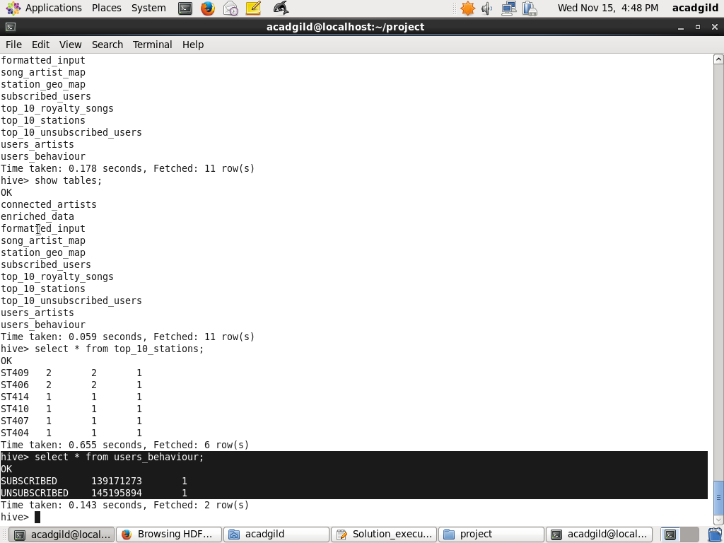

1. **Determine top 10 connected artists. Connected artists are those whose songs are most listened by the unique users who follow them.**

**Sol:**

CREATE TABLE IF NOT EXISTS connected_artists

(

artist_id STRING,

user_count INT

)

PARTITIONED BY (batchid INT)

ROW FORMAT DELIMITED

FIELDS TERMINATED BY ','

STORED AS TEXTFILE;

INSERT OVERWRITE TABLE connected_artists

PARTITION(batchid=${hiveconf:batchid})

SELECT

ua.artist_id,

COUNT(DISTINCT ua.user_id) AS user_count

FROM

(

SELECT user_id, artist_id FROM users_artists

LATERAL VIEW explode(artists_array) artists AS artist_id

) ua

INNER JOIN

(

SELECT artist_id, song_id, user_id

FROM enriched_data

WHERE status='pass'

AND batchid=${hiveconf:batchid}

) ed

ON ua.artist_id=ed.artist_id

AND ua.user_id=ed.user_id

GROUP BY ua.artist_id

ORDER BY user_count DESC

LIMIT 10;

**Output:**

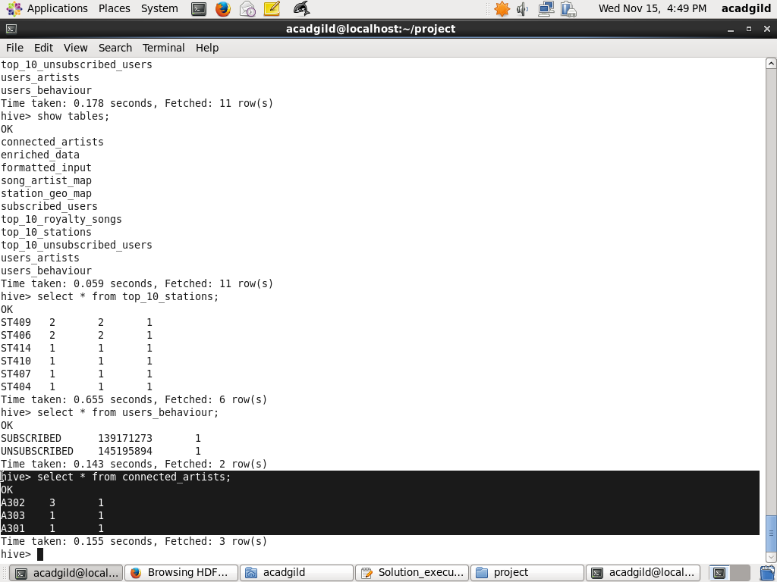

1. **Determine top 10 songs who have generated the maximum revenue. Royalty applies to a song only if it was liked or was completed successfully or both.**

**Sol:**

CREATE TABLE IF NOT EXISTS top_10_royalty_songs

(

song_id STRING,

duration INT

)

PARTITIONED BY (batchid INT)

ROW FORMAT DELIMITED

FIELDS TERMINATED BY ','

STORED AS TEXTFILE;

INSERT OVERWRITE TABLE top_10_royalty_songs

PARTITION(batchid=${hiveconf:batchid})

SELECT song_id,

SUM(ABS(CAST(end_ts AS DECIMAL(20,0))-CAST(start_ts AS DECIMAL(20,0)))) AS duration

FROM enriched_data

WHERE status='pass'

AND batchid=${hiveconf:batchid}

AND (like=1 OR song_end_type=0)

GROUP BY song_id

ORDER BY duration DESC

LIMIT 10;

**Output:**

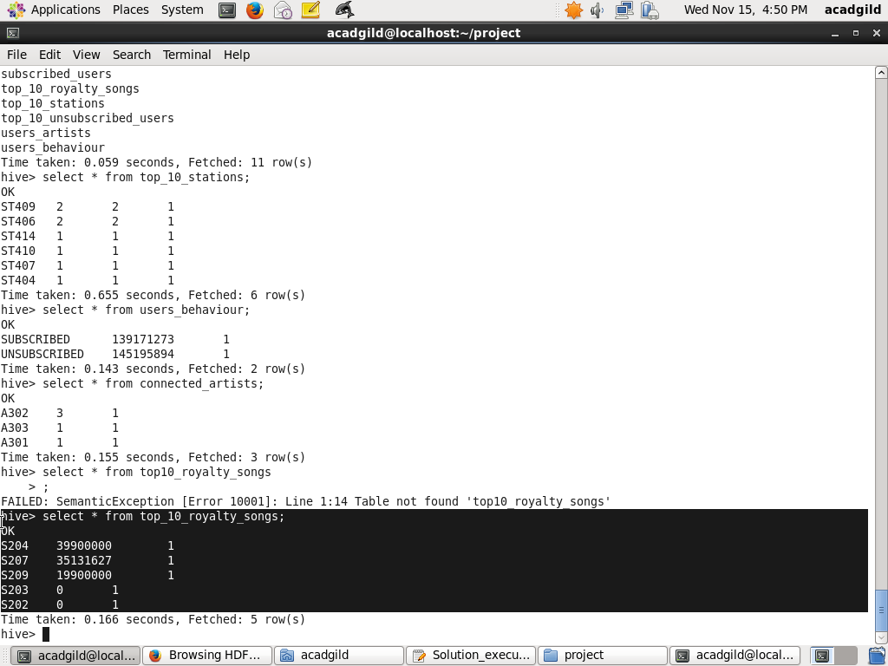

1. **Determine top 10 unsubscribed users who listened to the songs for the longest duration.**

**Sol:**

CREATE TABLE IF NOT EXISTS top_10_unsubscribed_users

(

user_id STRING,

duration INT

)

PARTITIONED BY (batchid INT)

ROW FORMAT DELIMITED

FIELDS TERMINATED BY ','

STORED AS TEXTFILE;

INSERT OVERWRITE TABLE top_10_unsubscribed_users

PARTITION(batchid=${hiveconf:batchid})

SELECT

ed.user_id,

SUM(ABS(CAST(ed.end_ts AS DECIMAL(20,0))-CAST(ed.start_ts AS DECIMAL(20,0)))) AS duration

FROM enriched_data ed

LEFT OUTER JOIN subscribed_users su

ON ed.user_id=su.user_id

WHERE ed.status='pass'

AND ed.batchid=${hiveconf:batchid}

AND (su.user_id IS NULL OR (CAST(ed.timestamp AS DECIMAL(20,0)) > CAST(su.subscn_end_dt AS DECIMAL(20,0))))

GROUP BY ed.user_id

ORDER BY duration DESC

LIMIT 10;

**Output:**

